Collection

Collections

Collection API (Collection framework)

Collection (In.) ---extends🡪 List (In.), Queue(In.), Set(In.) [All of these are interfaces]

Collection extends Iterable

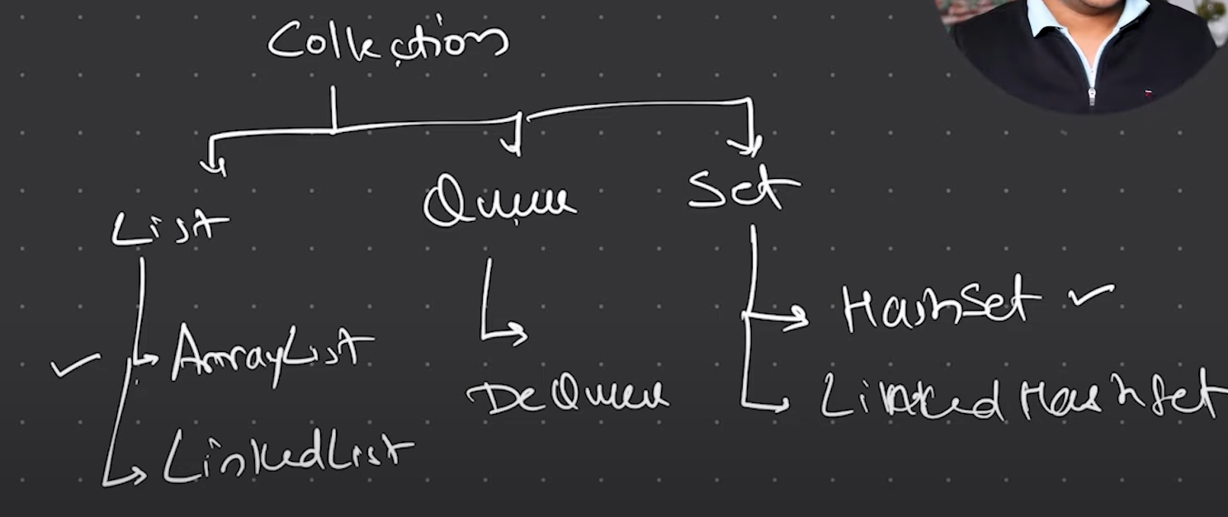

ArryList, LinkedList, Dequeue, Hashset, Linked HasSet these are the classes which implements those collections.

\*\*Using Collection (In.) and ArrayList (Cl.)



